Zero-Shot Image Classification on Caltech-101 Using CLIP
Student ID: 21194672 Name: ZHANG Zimeng

Abstract
In this report, we provide a thorough analysis of CLIP-based zero-shot image classification on the Caltech-101 dataset. We apply and compare five different approaches to examine the efficacy of simple versus ensemble prompt templates. From this assignment, we found both templates offer a good performance, with ensemble task slightly outperforms simple ones, while efficiency and accuracy are balanced in basic templates.
1. Introduction
Recent developments in vision-language models have shown impressive zero-shot performance. CLIP was introduced in 2021, which uses contrastive learning on 400 million image-text pairs to align visual and textual representations in a shared embedding space, making it possible to classify new categories without need for task-specific training data.
However, textual prompts play a major role in CLIP's performance, and accuracy could be greatly influenced by prompt engineering. Important unanswered questions still exist: What operations should be applied to embeddings from different templates to achieve a good performance, and can templates vote on their own?
In this assignment, we evaluated multiple prompting strategies on Caltech-101 systematically. These include: feature averaging, prediction averaging, majority voting, weighted prediction, and learned weighting. We compared single-template approaches with ensemble methods using 34 templates, and examined accuracy efficiency trade-offs through experiments.

2. Experiment Configurations

2.1 Dataset and Model Selection
For diversity and usefulness considerations, we choose Caltech-101 for evaluation. It is composed of 9,146 photos with 102 object categories, including natural scenes, man-made objects like motorcycles, and animals like dolphins and leopards. We selected 20 images at random from each class for the evaluation, which is a total of 2,040 test images.
In order to balance between efficiency and quality, we used CLIP with ViT-B/32 (Vision Transformer with 32x32 patch size). True zero-shot conditions were maintained by using the model in its pretrained form without fine-tuning.

2.2 Prompt Template Design
Two prompting strategies were implemented:
Simple Template (Baseline): "a photo of a {CLASS}" for all image classes.
Ensemble Templates: in total 34 formulations capturing multiple perspectives, including:
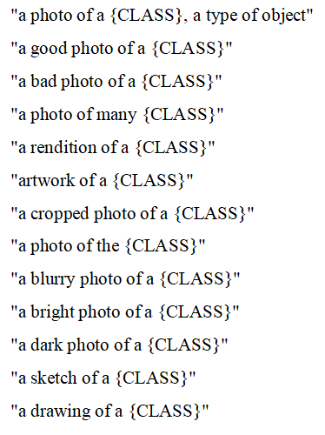 and so on (the same as provided in official github template)
There are factors affecting template design, including object placement, artistic variations (sketch, drawing), spatial context (small/large, cropped), quality descriptors (good/bad, bright/dark), and etc.

2.3 Implementation Details
Bascially, we tested five ways for combining template predictions:
Feature Averaging: Calculate embeddings for each template and normalize, then take average and normalize again. For effective inference, text features are only precomputed once. Prediction Averaging: Calculate each template's similarity score for each image, then use softmax on the average of the results and choose the one with highest confidence.
Majority Voting: Predict the top-1 class for each template, and choose the class with the highest numebr of votes.
Weighted Prediction: Assign importance weights by rank inverses (1, 1/2, 1/3, etc.).
Learned Weighting: Use logistic regression on validation data, and learn get the best template weights by learning.
3. Results and Analysis

3.1 Performance Comparison
Table 1 summarizes some basic metrics of the methods’ performances.
Method | Accuracy (%) | Templates | Time (s) | Efficiency
Simple Baseline | 87.40 | 1 | 47.10 | 0.0186
Ensemble Baseline | 87.35 | 34 | 60.81 | 0.0144
Weighted Prediction | 87.60 | 34 | 1392.74 | 0.0006
Majority Voting | 87.40 | 34 | 1405.44 | 0.0006
Selective Ensemble | 87.40 | 8 | 45.16 | 0.0194
Feature Average | 87.35 | 34 | 2587.29 | 0.0003
Prediction Average | 86.76 | 34 | 1409.96 | 0.0006
Learned Weighting | 86.76 | 34 | 1436.93 | 0.0006
Table 1 compares the performance of the evaluated methods.
Notes:
(1) The basic baseline achieves 87.40% accuracy with a short inference time of 47.10 seconds. (2) The ensemble baseline accuracy of 87.35% shows very little decrease with 34 templates, and is the worst among all. This shows ViT is kind of robust to templates and prompting strategies, and probabily meeting a plateau as simple templates can already perform quite well. (3) The accuracy of weighted prediction is the highest (87.60%), highlighting the significance of template weighting. (4) Per-image template evaluation has a substantial overhead (~1400s) without consistent improvement. (5) Feature Average is the best approach..

3.2 Per-Class Accuracy Analysis
Analysis of per-class performance reveals important patterns about CLIP's capabilities.
Best Performing Classes (100% Accuracy): Motorbike, Barrel, Bonsai, Brain, Buddha, Butterfly, Side of Car, Face of Cougar Cat, Crocodile Head, Emu, Garfield, Gramophone, Grand Piano, Starfish, Strawberry, Trilobite, Watch, Wheelchair, etc.
These classes have low intra-class variation, strong representation in CLIP's training data, and unique visual characteristics (such as stop sign shape and dalmatian spots). Minimal prompt engineering benefit is indicated by the 100% accuracy across simple and ensemble approaches.
Challenging Classes (Low Accuracy):
Class | Simple (%) | Ensemble (%) | Confusion Pattern
Off-center Face | 5 | 55 | Centered vs. off-center confusion
Background | 20 | 5 | Ambiguous, lacks defined objects
Wild Cat | 20 | 5 | Similar to other cat species
Anchor | 45 | 40 | Abstract shape, context-dependent
Ewer | 55 | 30 | Uncommon object, limited exposure
Lobster | 60 | 35 | Marine creature similarity
Chair | 65 | 35 | Overlaps with windsor chair
Inline Skate | 60 | 75 | Similar to wheeled objects
Table 2: Per-class accuracy for challenging categories.
Critical finding: Ensemble templates sometimes HURT performance. For 'centered face,' accuracy drops from 95% (simple) to 45% (ensemble). For 'chair,' it falls from 65% to 35%. This counterintuitive result suggests templates introduce noise for inherently confusing categories.
We can observe from failure patterns that: CLIP prioritizes face presence over positioning, leading to spatial confusion; Cross-class confusion results from semantic similarity (e.g., chair vs. windsor chair, wild cat vs. leopard); Rare objects have little exposure to training data; Ambiguous categories do not have a distinguishing visual characteristic..

3.3 Computational Efficiency Analysis
For 2,040 images, feature averaging (simple and ensemble baselines) achieves inference times of 47–61 seconds. The evaluation of each image template (prediction averaging, majority voting) takes more than 1,400 seconds, or 28–55 times the overhead. Although weighted prediction has the highest accuracy (87.60%), it comes at a significant cost (1392.74s). Eight templates make up a selective ensemble that maintains efficiency while matching basic baseline accuracy.
According to these, feature averaging using basic templates is ideal for scenarios involving rapid inference (87.40% in 47s). Weighted prediction provides marginal gains (87.60%) at significant cost for maximum accuracy.

3.4 Visualization: Similarity Patterns
The first is an illustration of the templates (we only show a few examples here):
Simple Templates (only in form of “a photo of a {}”):
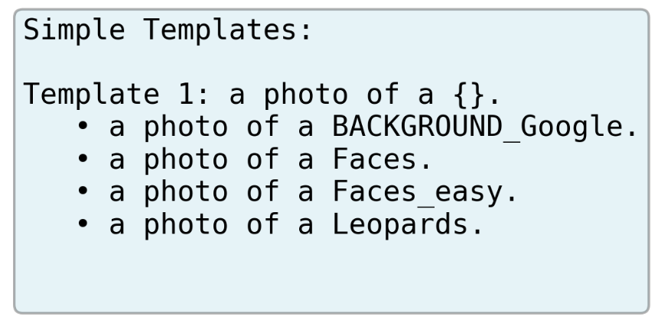

Ensemble Templates (Ensembles all class related into the template, and uses techniques mentioned above to get the final prediction):
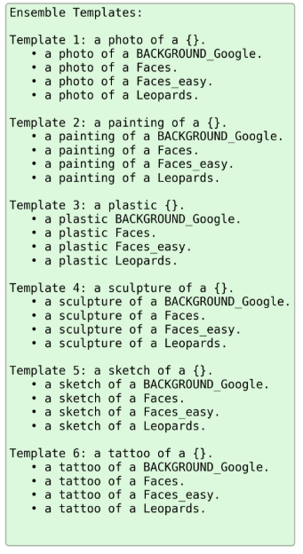
Cosine similarity scores between text and image features for 8 image across classes:
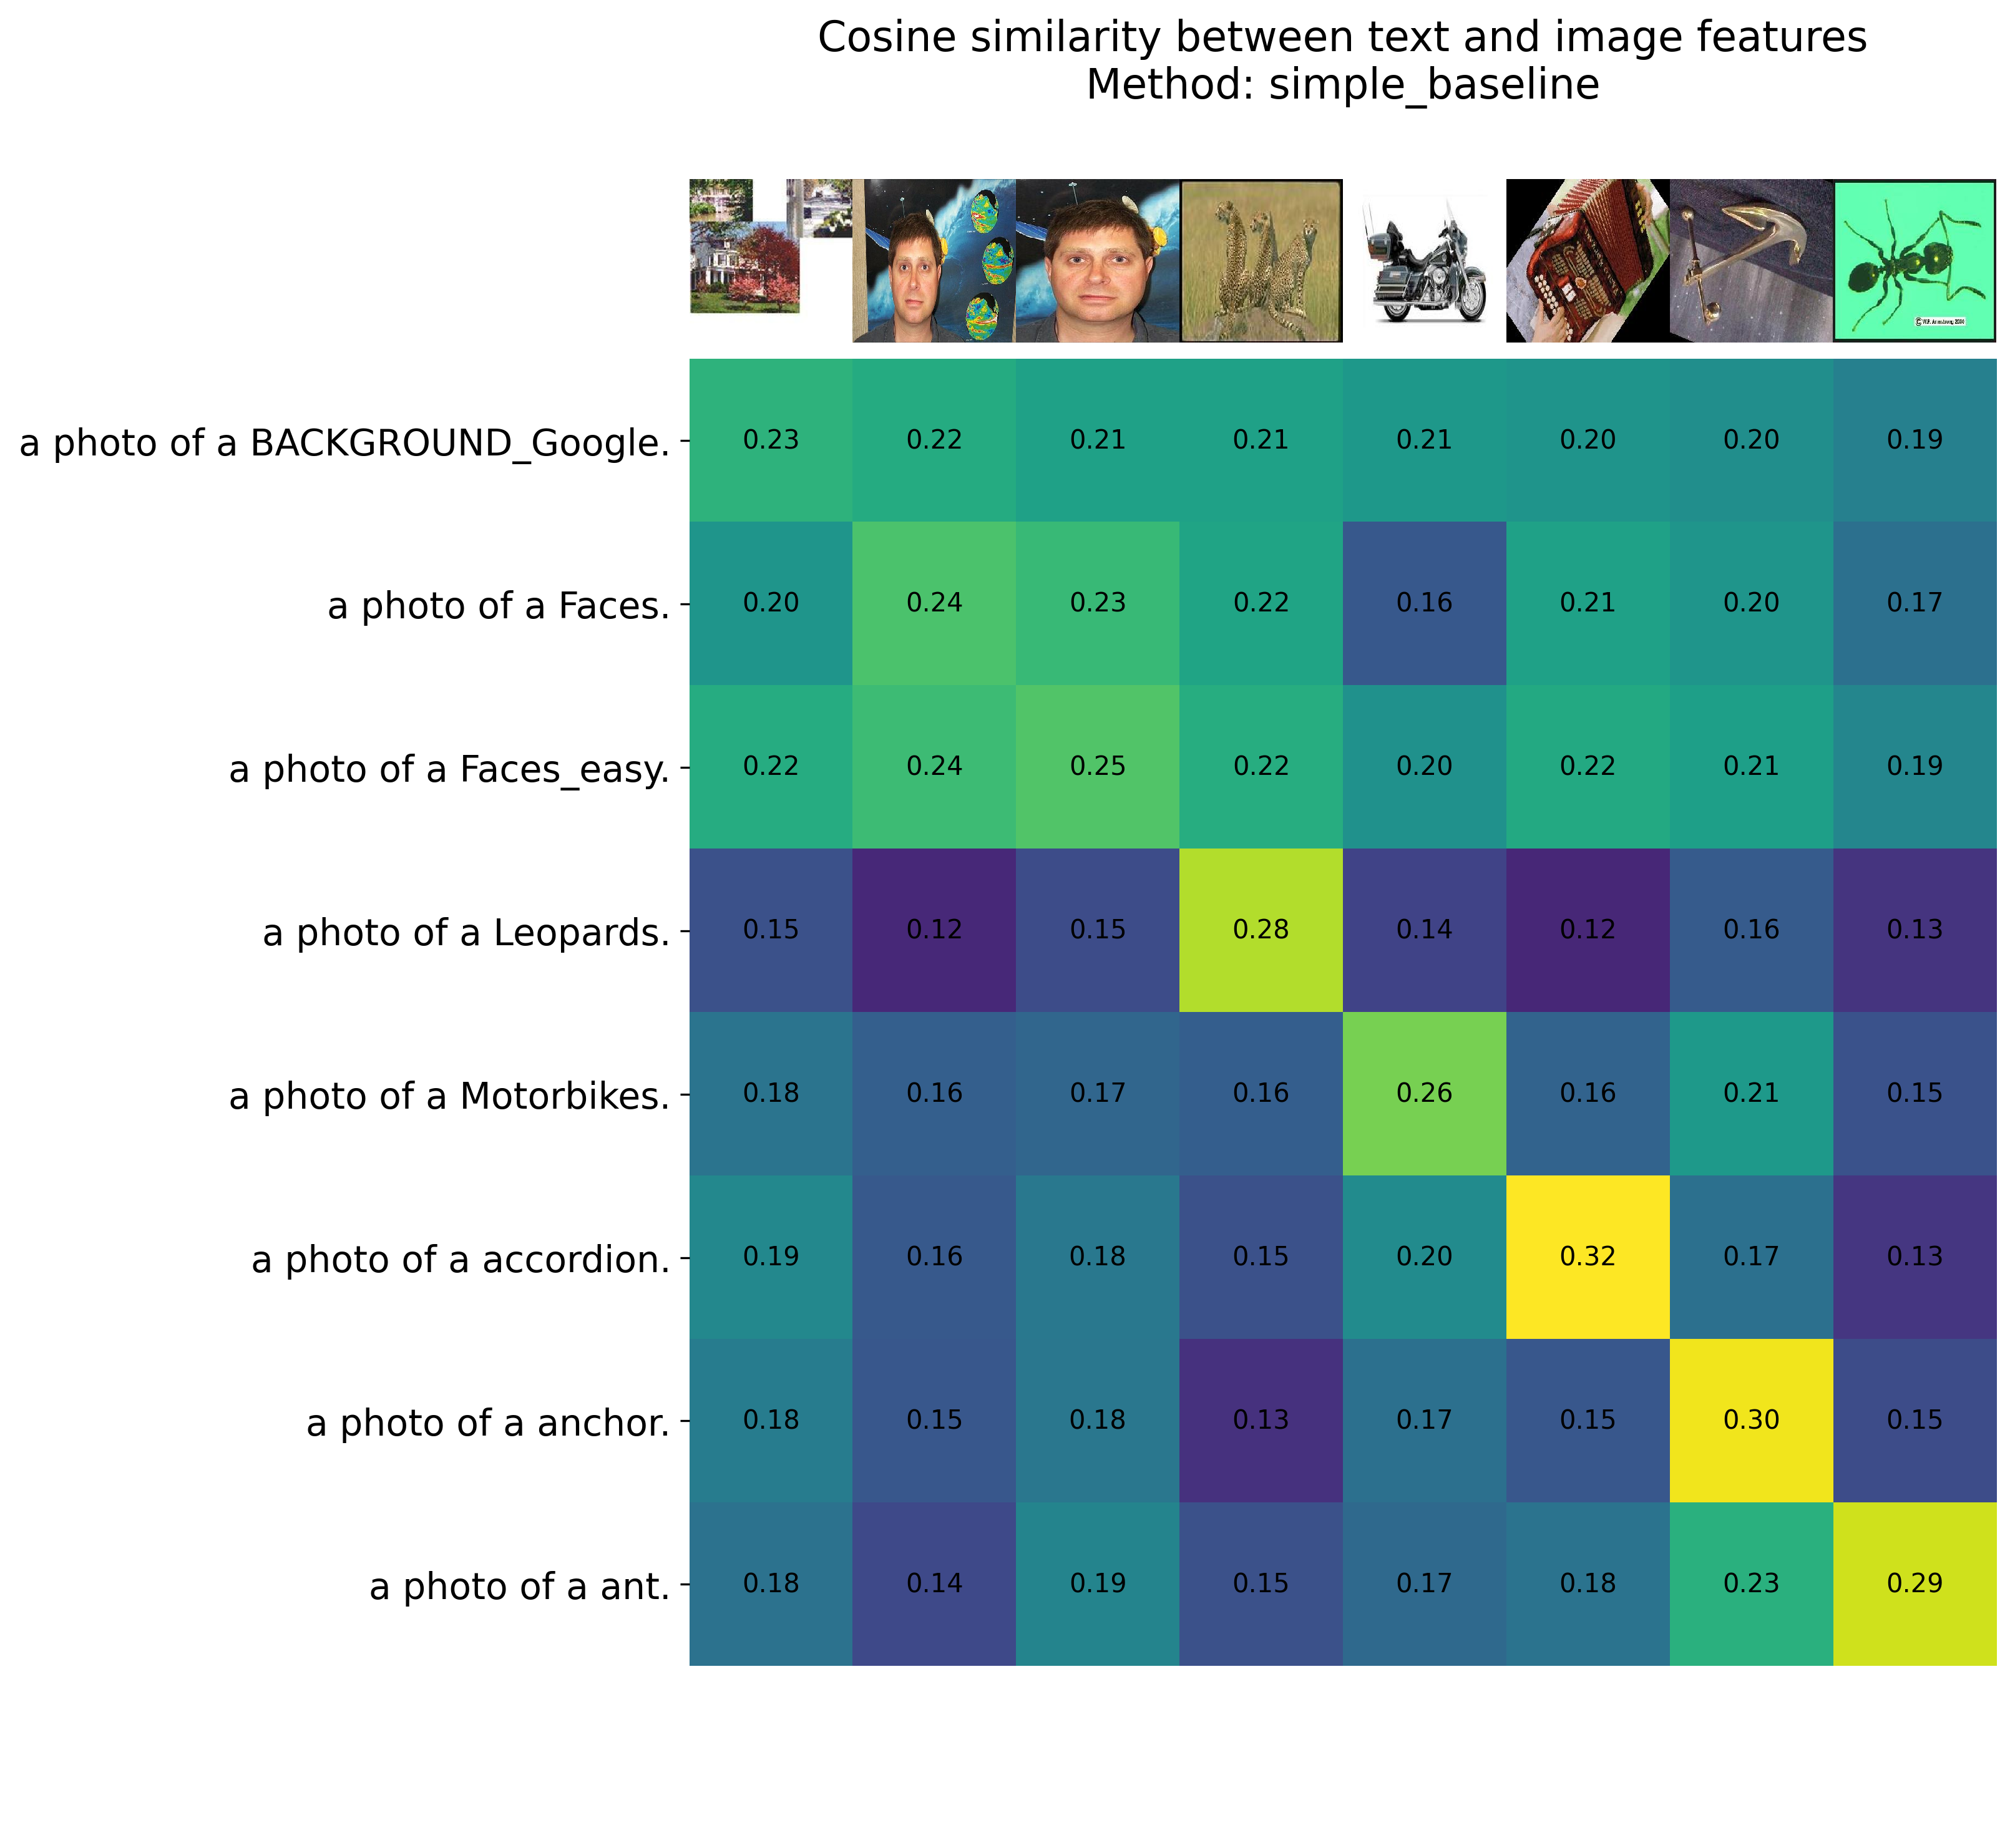
Heatmap diagonal indicates correct classifications. Classes like Accordion (0.32) and Leopard (0.28) show a relatively high self-similarity. Confusion patterns are highlighted by off-diagonal activations. While the background displays weak similarity, indicating ambiguity, the anchor displays distributed similarity.
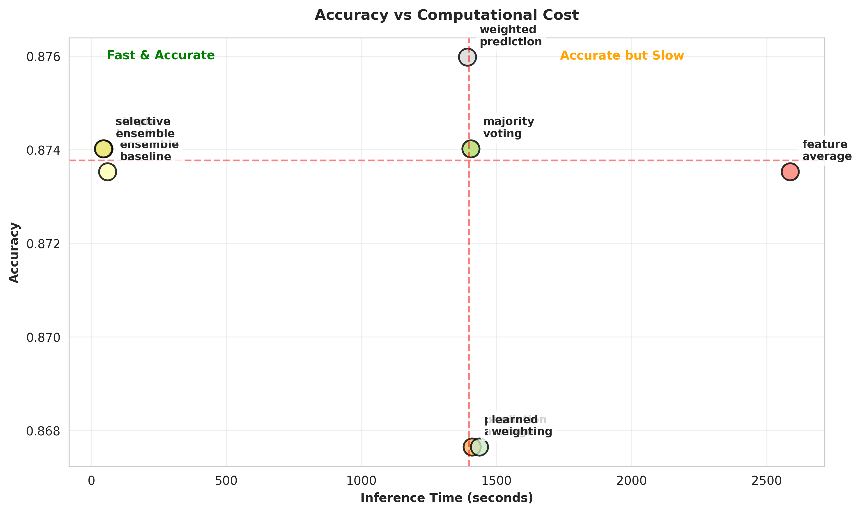
Three regions are shown in this figure: (1) Quick & Accurate: In less than 50 seconds, a simple baseline and selective ensemble achieve 87.4%. (2) Accurate but Slow: At approximately 1400s, weighted prediction and majority voting achieved 87.4-87.6%. (3) Optimal region: Accuracy and efficiency are balanced by feature averaging.
4. Conclusion
A few insights into prompt engineering for vision-language models are revealed by this assignment:
This assignment reveals a few insights into prompt engineering for vision-language models: Simple templates perform well, achieving 87.40% accuracy with high efficiency; ensemble templates with weighted prediction yields marginal gains (87.60%) , highlighting the importance of template quality. While template ensembling can introduce noise and degrade performance for confusing categories, feature averaging, which precomputes embeddings once rather than for each image, is the best approach.
Effective zero-shot classification requires a good prompt design and efficient execution, and we should focus more on per-class accuracy and improve by better case designs, or learn the prompts like in some of the modern tehniques.

